TEAM ID: PNT2022TMID08472

TEAM LEADER: MARIA MANOJ KUTTOMPARAMBIL

TEAM MEMBER 1:K.KAVYA

TEAM MEMBER 2:A.BHUVANESHWARI

TEAM MEMBER 3:A.AGASHIYA

PROCEDURE FOR IBM WATSON IOT DEVICE CREATION:

* ***To connect IOT devices with IBMPLATForm***

Step 1: Go to IBM cloud and click catalog. Now select services and then select Internet Of Things and Internet of Things Platform.

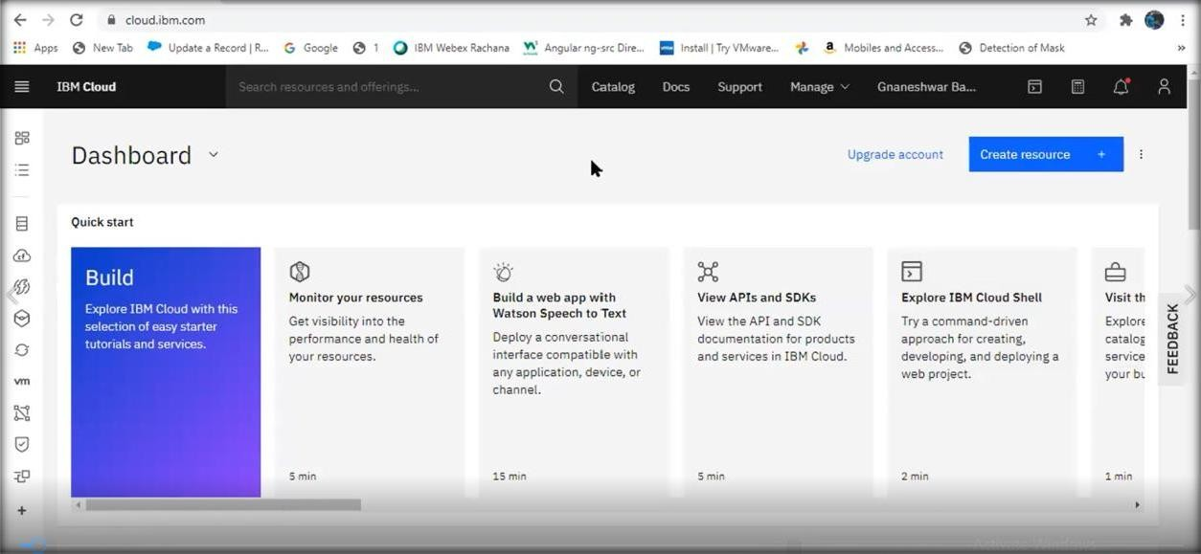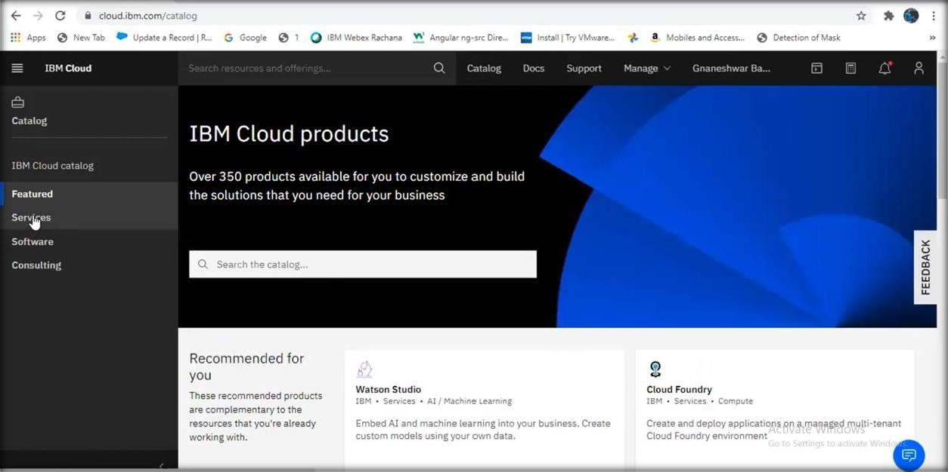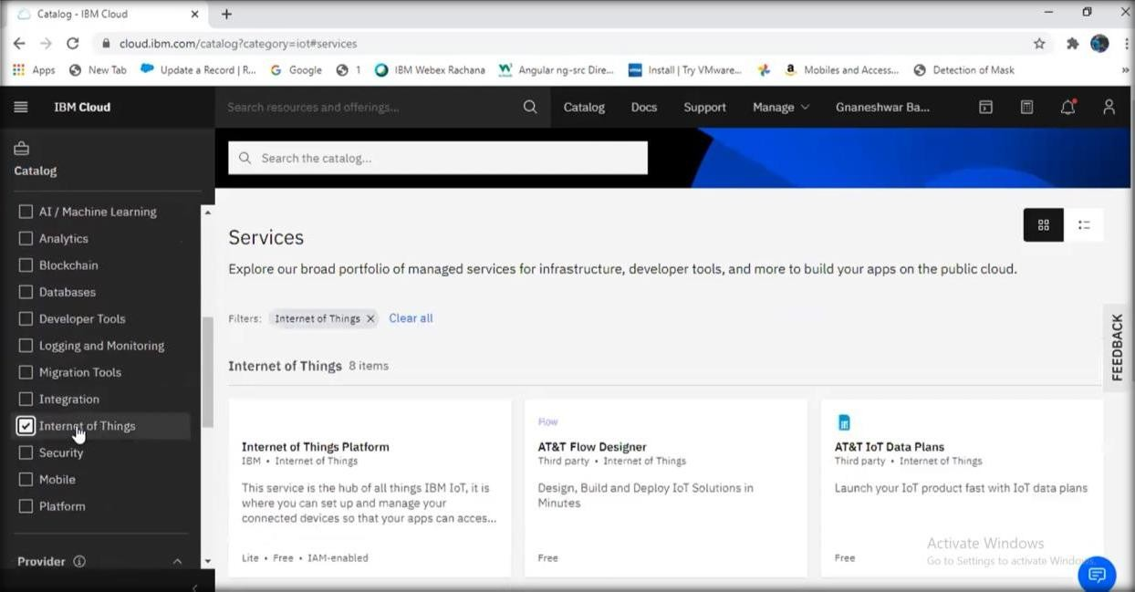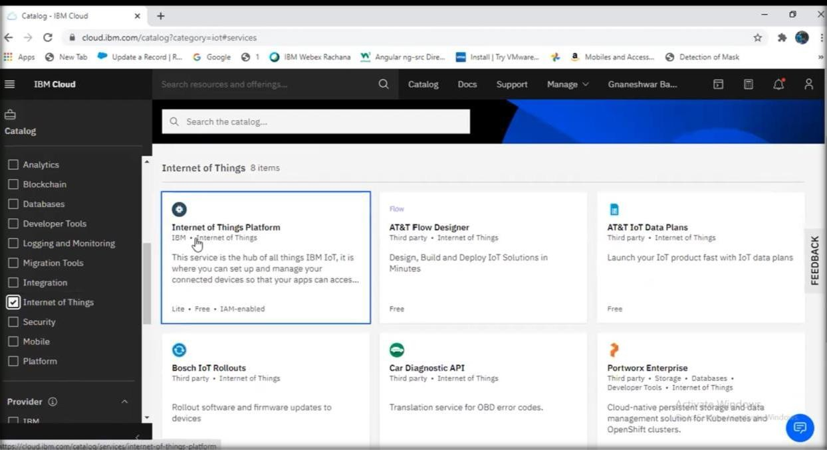

Step 2: Now you will be redirected to a new page. Here, select the region, pricing plan and service name and click create.

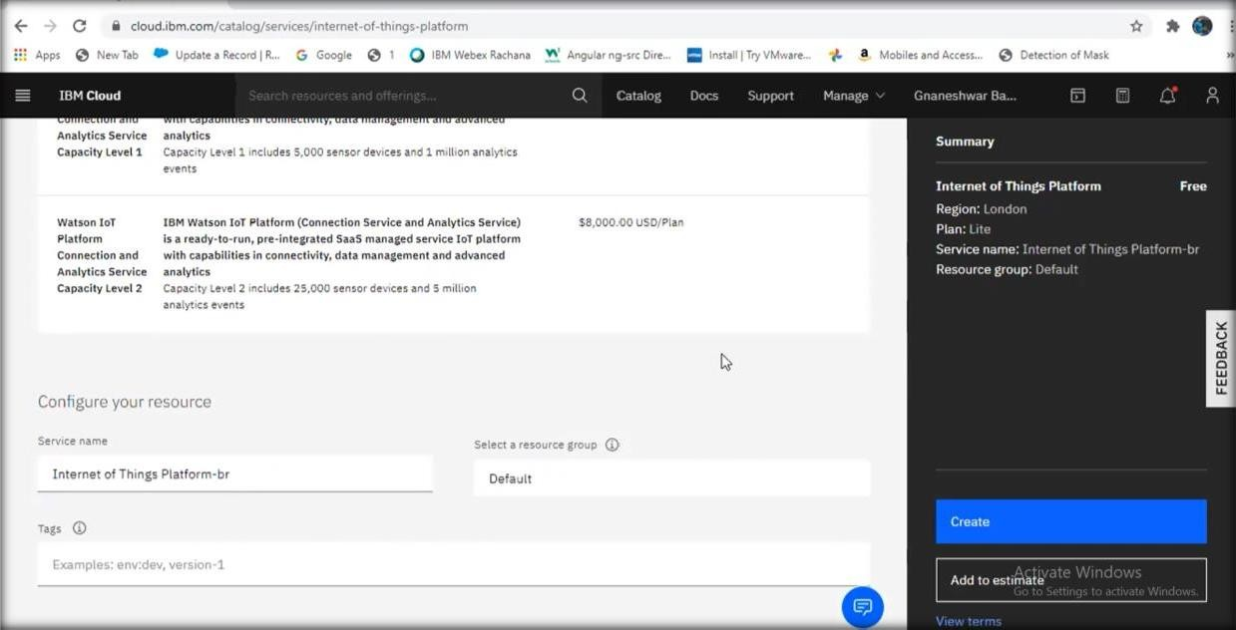

Step 3: As a next step you’ll be redirected to the page ‘Internet Of Things Platform-br’.Here click launch.

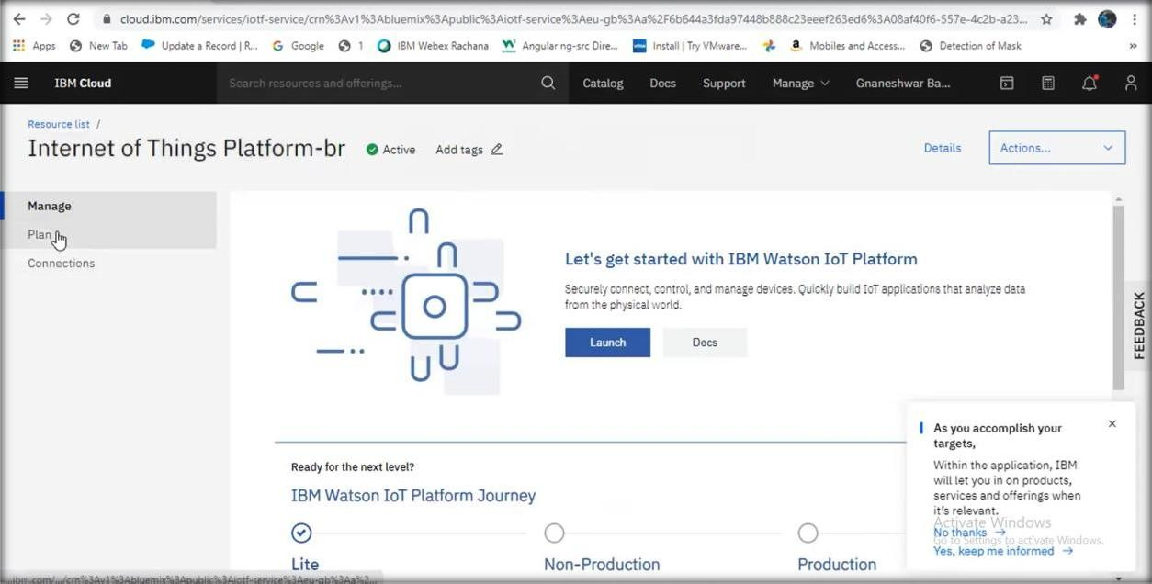

Step 4: IBM Watson IOT Platform will be launched. Click on sign in and login using your IBM registered credentials.

Step 5: Under devices, click create device. Enter the device details and click finish.

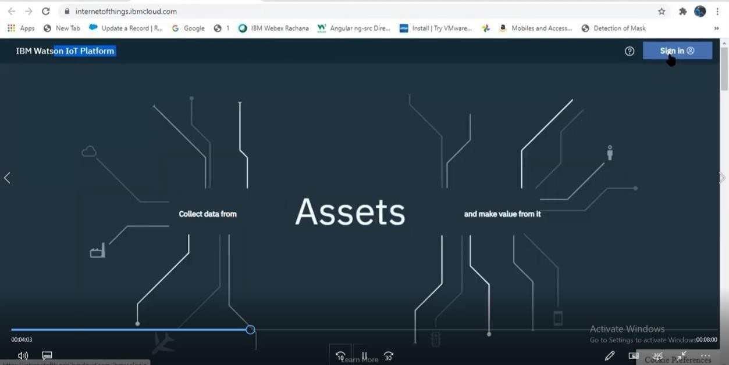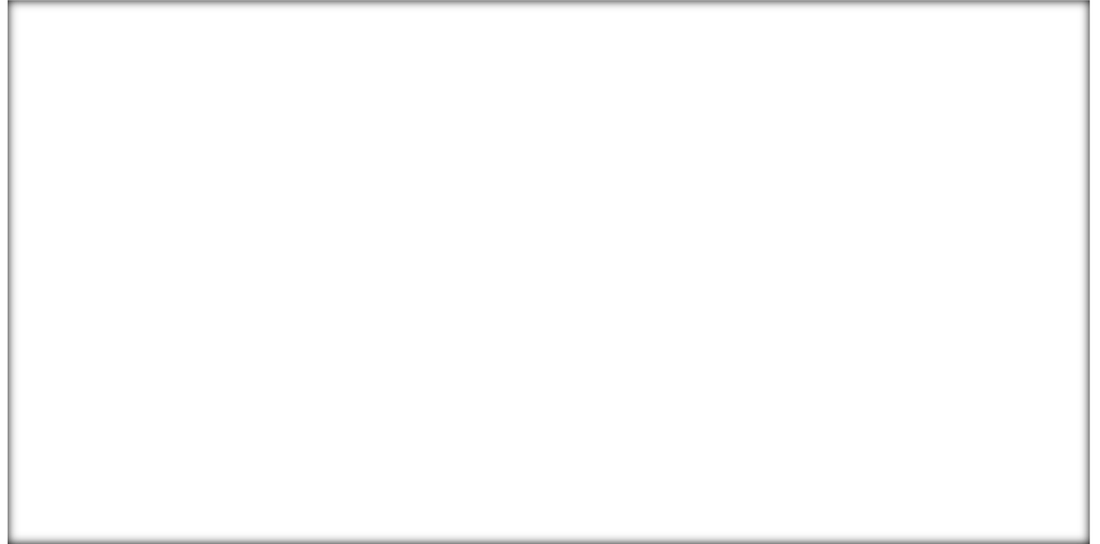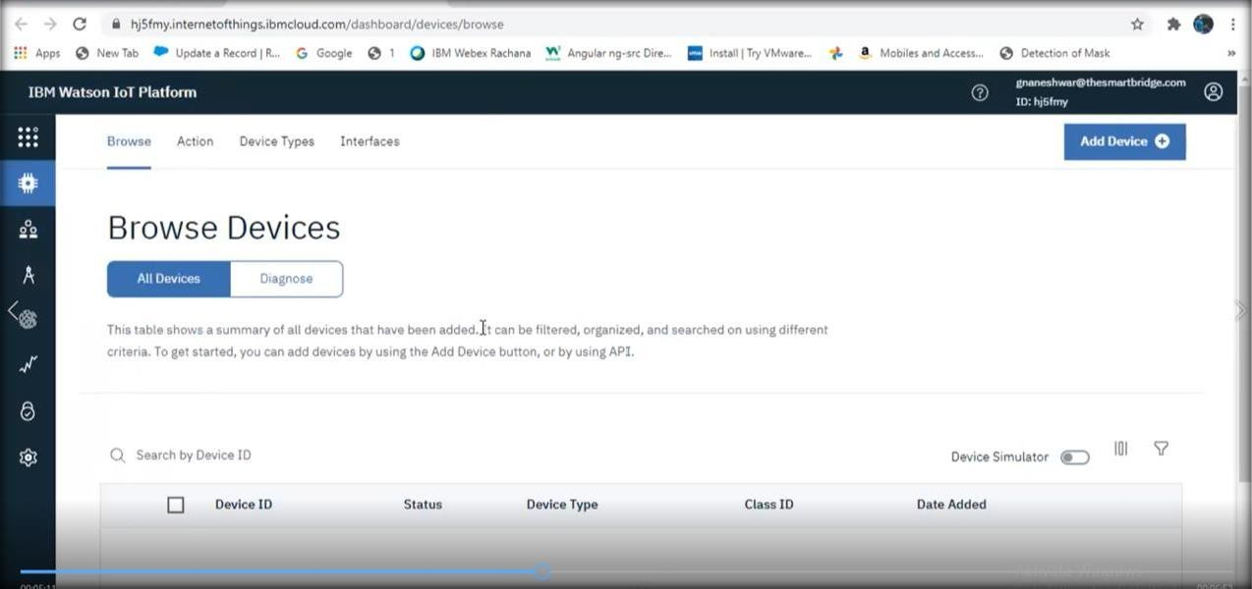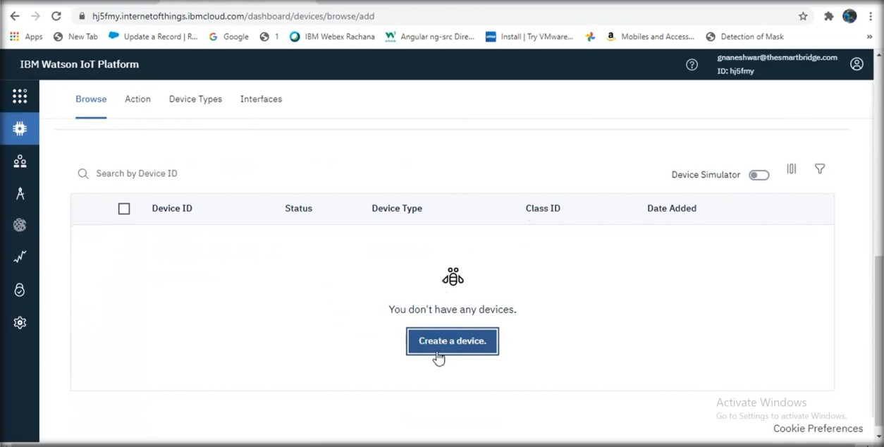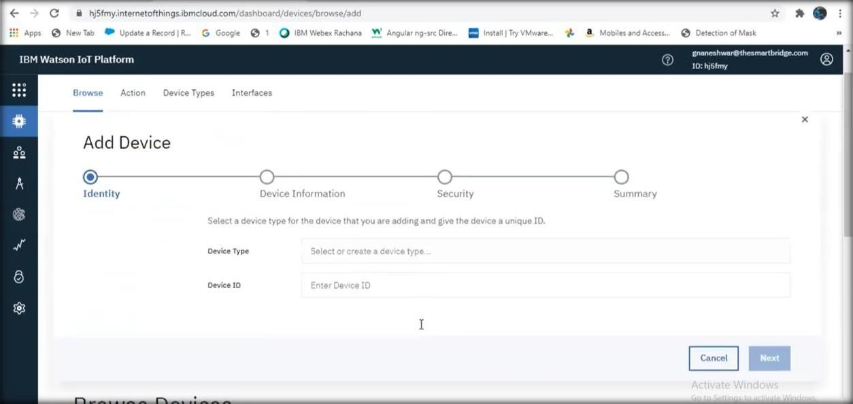

Step 6: Thus the IOT device is created. Copy the device credentials into a notepad.

